GEOCOCCYX VELOX BLOG 2019.

The first event for 2019 was the HSCCQ Come and Try Motorkhana / Khanacross at Willowbank on 24th February. The car would not start – battery flat. Jumper battery also flat. Brought it home, charged battery, and it started first touch. Brake master cylinder caps all breaking apart at layers in the threads. Next day I bought 4 new brake master cylinder caps from Supercheap, and fitted them. Butchy revealed he had the same problem, so I gave one of my new brake master cylinder caps to him, and bought a replacement for Geo.
Sunday 14-4-2019. Interclub Motorkhana, Willowbank. Scrappy run in Star. but 22.49 fastest first run. 24.19 +5 second run. 2nd outright. The engine was surging in first run at Eccentric, (37.15), back to pits, top up with fuel, then it would not start. Battery flat. Connected jump start battery at home, and it started first go. On Sunday 19-5-2019 I tried to start car, but battery is flat. Charged battery and jump start battery, and next day it started first click.
Sunday 16-6-2019. HSCCQ Khanacross / Motorkhana at Willowbank. Ran slicks on the puddles in the Motorkhana, and did 3 runs at Straight Slalom. Best time 21.22 (fastest outright).Then battery went flat, and the jumper battery also. Did one run at Knitting in Terry’s Skyline, recording 44.59, 0.59 slower than Terry, but faster than Noel.
Sunday 14-7-2019. Installed new labels on dashboard.
Sunday 28-7-2019. Both batteries flat and do not start car. Charged them both, and car battery started engine OK. Sunday 4-8-2019. Batteries will not start car. Charged them, and it started on car battery.
Tuesday 6-8-2019. New battery from Battery World, $110. Charged it, fitted it, and it started first go.
Sunday 11-8-2019. Geo started first pop on its own battery.
Wednesday 14-8-2019. Installed new starter solenoid, and started engine OK.
Sunday 18-8-2019. HSCCQ Khanacross / Motorkhana at Willowbank. The engine overheated after the second run in the motorkhana, and the fan would not work. In the second run at the top khanacross, at full revs in second gear over some giant bumps, the left rear suspension pushrod broke, and the suspension collapsed. Top Khanacross Run 1. 51.21 seconds (2nd to Stuart Bell) Open Slalom Run 1. 22.10 (2nd to Brant).

Sunday 22-9-2019. QMC at Willowbank Raceway. Engine not running well, seemed to be starving of fuel sometimes. I took the fuel pump off, and blew through it backwards, and it seemed to improve for 1 test.
- Serpentine. 22.21 second to Brant.
- Pine Tree. 17.60
- Hopkirk. 41.34 trouble with gears.
- Paddy. 49.41 trouble with gears.
- Gate Slalom mirror. 24.53 5th
Monday 7-10-2019. Took fuel pump and its mounting tray off, shifted them to beside the gearbox, rewired it, and re-routed the fuel lines.
Friday 11-10-2019. Pick up radiator from Valley Radiator Works, there was a groove in the outlet pipe that was causing the leak. $50. Fitted it, and filled with coolant. Fitted new fuel filter.
Friday 18-10-2019. Ordered replacement TPS from South Australia.
Monday 21-10-2019. Ordered a brand new TPS from DH gate.com.
Saturday 26-10-2019. Tested spare (original) TPS with multimeter, and it “seems” to be OK. Sunday 27-10-2019. HSCCQ Interclub Khanacross. Willowbank Raceway. Problems with intermittent cutting out, and starter seemed to occasionally jamb on
Monday 28-10-2019. TPS arrived from South Australia. Typical !!!!!
Tuesday 29-10-2019. Installed new TPS, and started car. All seemed OK till the engine warmed up, then it stalled when on the over-run. Then it would not run at a steady throttle. I adjusted the TPS throughout its whole range, and it kept doing the same thing.
Thursday 31-10-2019. Tyres on trailer wheels swapped at Jax, Michelton. $50. Fitted them onto trailer.
Friday 1-11-2019. Moved cutoff master switch to be accessible from outside of vehicle. Started OK.
Saturday 2-11-2019. Removed padding from steering rack, and built an aluminium shield for it. Painted and fitted it.
Wednesday 6-11-2019. To Team Moto, Alderley. Asked them about the Diagnosis plug. They are only on bikes after 2003, and before that the diagnosis was done through the dashboard. They did not seem to be helpful, so I chased alternative motorcycle mechanics.
Tuesday 12-11-2019. Bought new multimeter, and tested TPS that is fitted to car. Problems with calculating operating range, so fitted it in central position. Wednesday 13-11-2019. Started engine, but it cut out straight away. Repositioned TPS, and it started well, and warmed up normally.
Friday 15-11-2019. TPS from DH Gate, USA arrived in mail. It does not look brand new.
Sunday 17-11-2019. HSCCQ Motorkhaha / Khanacross, Willowbank. Fine, very hot. Started car on jumper battery, and warmed it up. It then simply cut out. Noel came to investigate, and reset TPS, but it still cutout when warm. Then the starter motor jammed, and was working as soon as the master switch was turned on. Brought it home, and took all the panels off. Took off new starter solenoid, and put the original one back on. Found that the live terminal was oversize, and was possibly shorting out on the mounting plate. Insulated it with tape, and re-installed it. All now works perfectly. However the motor cuts out when warm. Found the coolant temperature sensor, and tested engine with the temp sensor unplugged. Engine ran fine, so connected the sensor, and it stalled. Repeated the procedure and got the same results. Removed the water temperature sender, and cleaned it. Tested it again connected and it stalled, but stalled with the sensor unplugged. My diagnosis of a bad sensor is destroyed. Battery went flat, so charged it.

Monday 18-11-2019. Took Geo to Motorcycle Mad at Brendale. They diagnosed a crack in the exhaust system, which is causing the O2 sensor to shut down the ECU.
Tuesday 19-11-2019. Electronic dashboard arrived.
Wednesday 20-11-2019. Ordered exhaust mandrels and expanders from Mac’s Mufflers, Enoggera. Draw exhaust headers and jig. Started making exhaust headers jig.
Thursday 21-11-19. Picked up 4mandrel bends 38 OD x 180 degrees, and 2 x 1.5 metres of 38 OD pipe with expanded ends from Mac’s Mufflers, Enoggera. $125. Worked on drawings of headers.
Friday 22-11-2019. To Alltype to pick up header connectors. Work on headers drawing and jig. Then I started manufacturing the new headers, and after lots of problems final finished them on 15th of December. 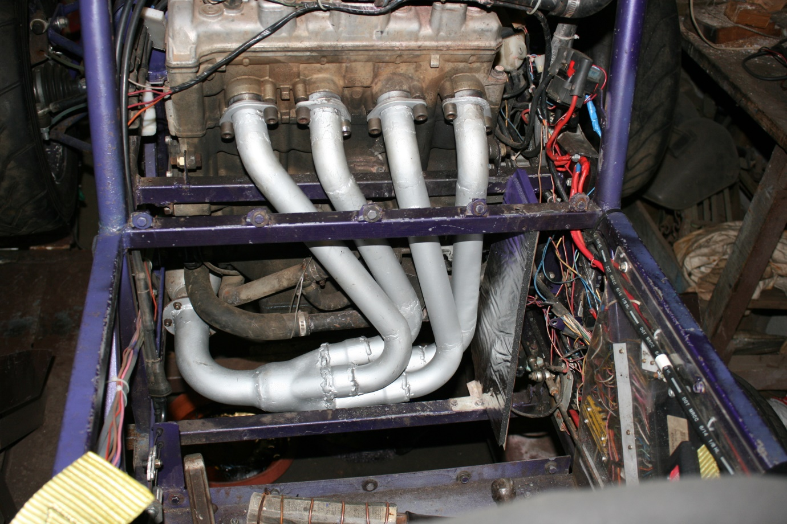 I got a larger replacement radiator from a Ninja 650, and built new brackets for it, and it was complete on 17th December. 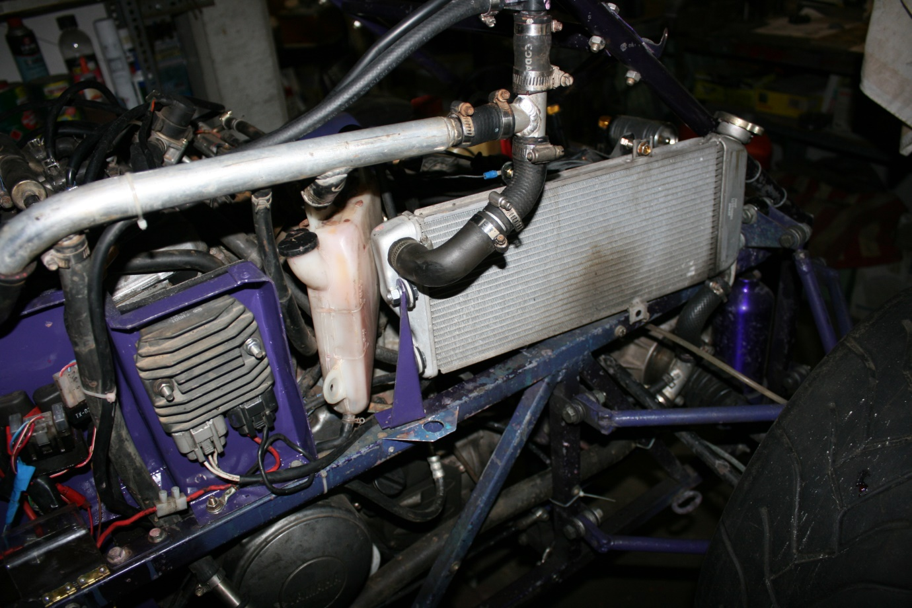
Thursday 19-12-2019. Took car back to Brendale, and noticed that the LR suspension had been broken again. Engine started perfectly, and ran quietly and smoothly. Injectors balanced, coolant “O” rings replaced, tune up etc. $220.

